**How to Start with React !**

**(codeSandBox.io 🡪 a react platform)**

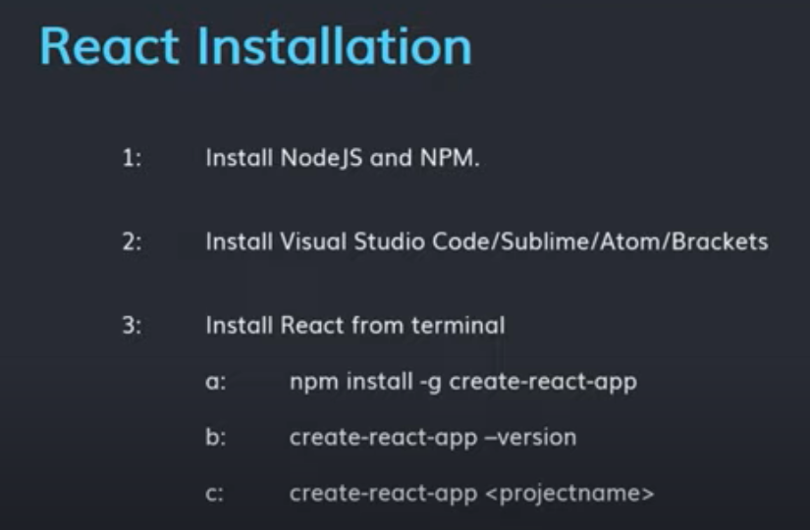

1. **Download and Install VS Code**
2. **Install Plugins**

* **Babel JavaScript**
* **ES6 Code Snippet**
* **VSCode-icons**

1. **React Installation**

* **Install NodeJS and NPM**

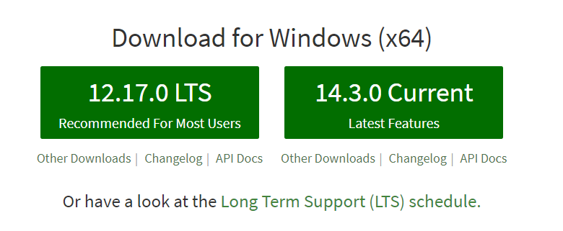

* **Download latest version of NodeJS and install it.**
* **Check the installation**
* **Go to cmd, type node -v**

* **NPM comes along with NodeJS**
* **Check the installation**
* **Go to cmd, type npm -v**

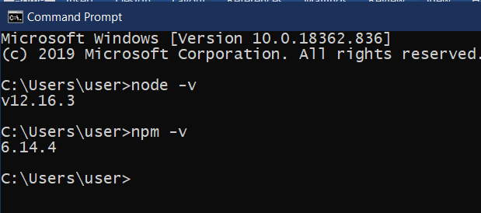

* **Installing create-react-app ie react globally using npm (node package manager)**
* **Run the below command anywhere**
* **>npm install -g create-react-app**
* **Check the version or installation**
* **>create-react-app --version**

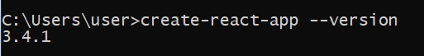

1. **Creating our first Project or React-app**
2. **Create a folder (just for cleanliness)**
3. **Go to that folder through command line**
4. **Suppose in D drive I have created a folder ReactProjects.**
5. **Use the command to create the first project**
6. **D:\ReactPrjoects> create-react-app react-demo**
7. **It will take some minutes to download its file.**
8. **Open the Project folder in VS Code to see the file structure.**

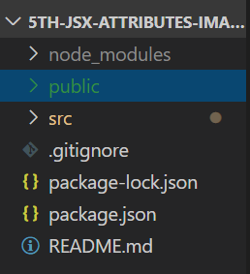

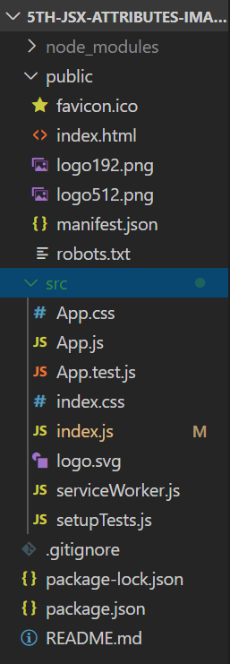

1. **So our first Project is ready to be run on the server.**
2. **Important files for now**

* **Index.js ->**
* **Index.html ->**

1. **Running the project**

* **Go inside the project folder.**
* **D:\ReactProjects\reactDemo>**
* **And run the command**

**npm start**

* **Eg. D:\ReactProjects\reactDemo>npm start**
* **Our project will be run on the browser(if there is no error in the code).**

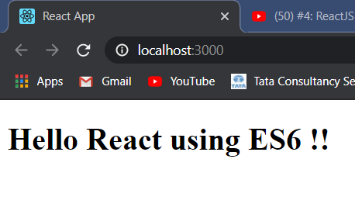

**I have changed the code in index.js.**